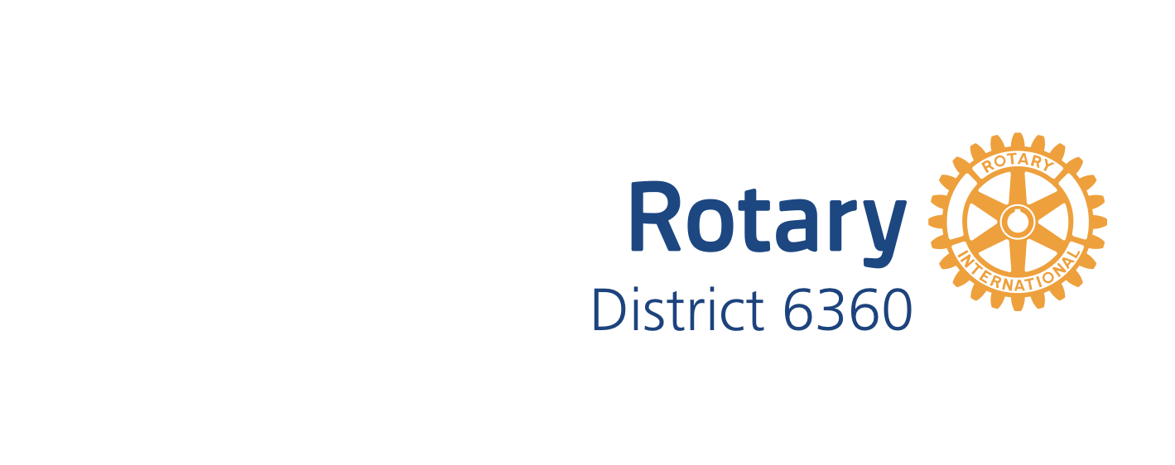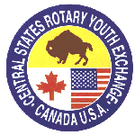**Rotary Youth Exchange**

**District 6360**

**Host Family Application Process**

Welcome! Your Rotary District 6360 Youth Exchange team is here to answer your questions on how to become a host family to a student from aboard. It will be a great experience for your family, with the right match of family to student.

To become a host family with Rotary Youth Exchange your family will need to complete the following steps.

1. **Complete the Host Family application.** The Link to the application is: <https://yehub.net/cgi-bin/CEN_get.cgi?pgid=aphf1>

* When completing the application, you will need to list two people that know you will to serve as a reference. These two people may not be relatives or members of Rotary District or Club Youth Exchange Officers.
* You will need to upload pictures of your home including kitchen, living space, the student’s bedroom and bathroom, your family, and an outside picture of your home.

1. **Background Checks**: Each member of your family over 18 will need to have a nation-wide criminal background check including sex offender register. We will need each person’s email address.
2. **Awareness Training:** Each member of your family over 18 will need to complete the “Youth Protection Awareness” module online and pass the quiz with 90% or higher. This is done by each person’s email address
3. **Home Visit**: The Rotary Club Youth Exchange Officer will visit your home and discuss the information on your application to decide if your home will be suitable match for the incoming exchange student. All members of the family should be present at this meeting.
4. **Additional support**: Your family will receive many references (available online and sent to you directly from the District Youth Exchange Chair). Also a Youth Exchange Officer and Youth Exchange Counselor will be assigned from your local Rotary club to work with you and the student.
5. Your family will participate in a **Host Family Orientation** after the above items are completed, and prior to student arrival. Many other specific items will be covered during this session.

Upon completion of the above steps, your family will receive an official ***“Welcome Letter***” from the United States State Department, which governs all foreign exchange student programs.

Please contact Cooper Frost, Inbound Student Coordinator or Margie Haas, District Chair with your questions. Let us know you are interested!!